[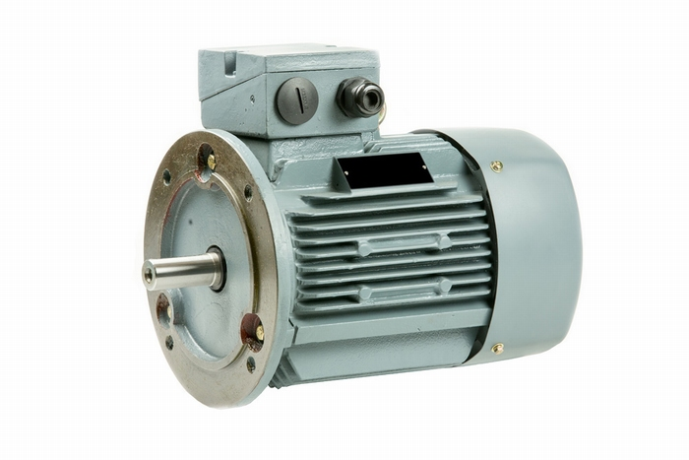](https://elektromotoren-online.nl/data/articles/images/zoom/m_1379.jpg)